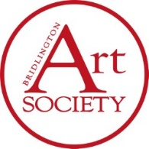 | Bridlington Art Society  Membership Application / Renewal Form
Subscription fees: Single £25.00 Couple £35.00
(Cheques made payable to Bridlington Art Society, or you can request BACS details)
Name:
Address: |  |  | Postcode:
Telephone: |  | Email:
Date: |  | Signed:
PLEASE RETURN THIS FORM & MEMBERSHIP SUBSCRIPTION TO:
Bridlington Art Society: Graham Wood, Jan Gregory, or Jackie Felber
This can be done at a monthly demonstration (Friday), or via the contact page
You will be issued with a membership card and receipt. Please note that a record of your name and contact details will be kept on a computer for club use only. They will not be shared with any third party.

