BRIDLINGTON ART SOCIETY EXHIBITION at RSPB BEMPTON CLIFFS*

CELEBRATING the WILDLIFE of the EAST COAST

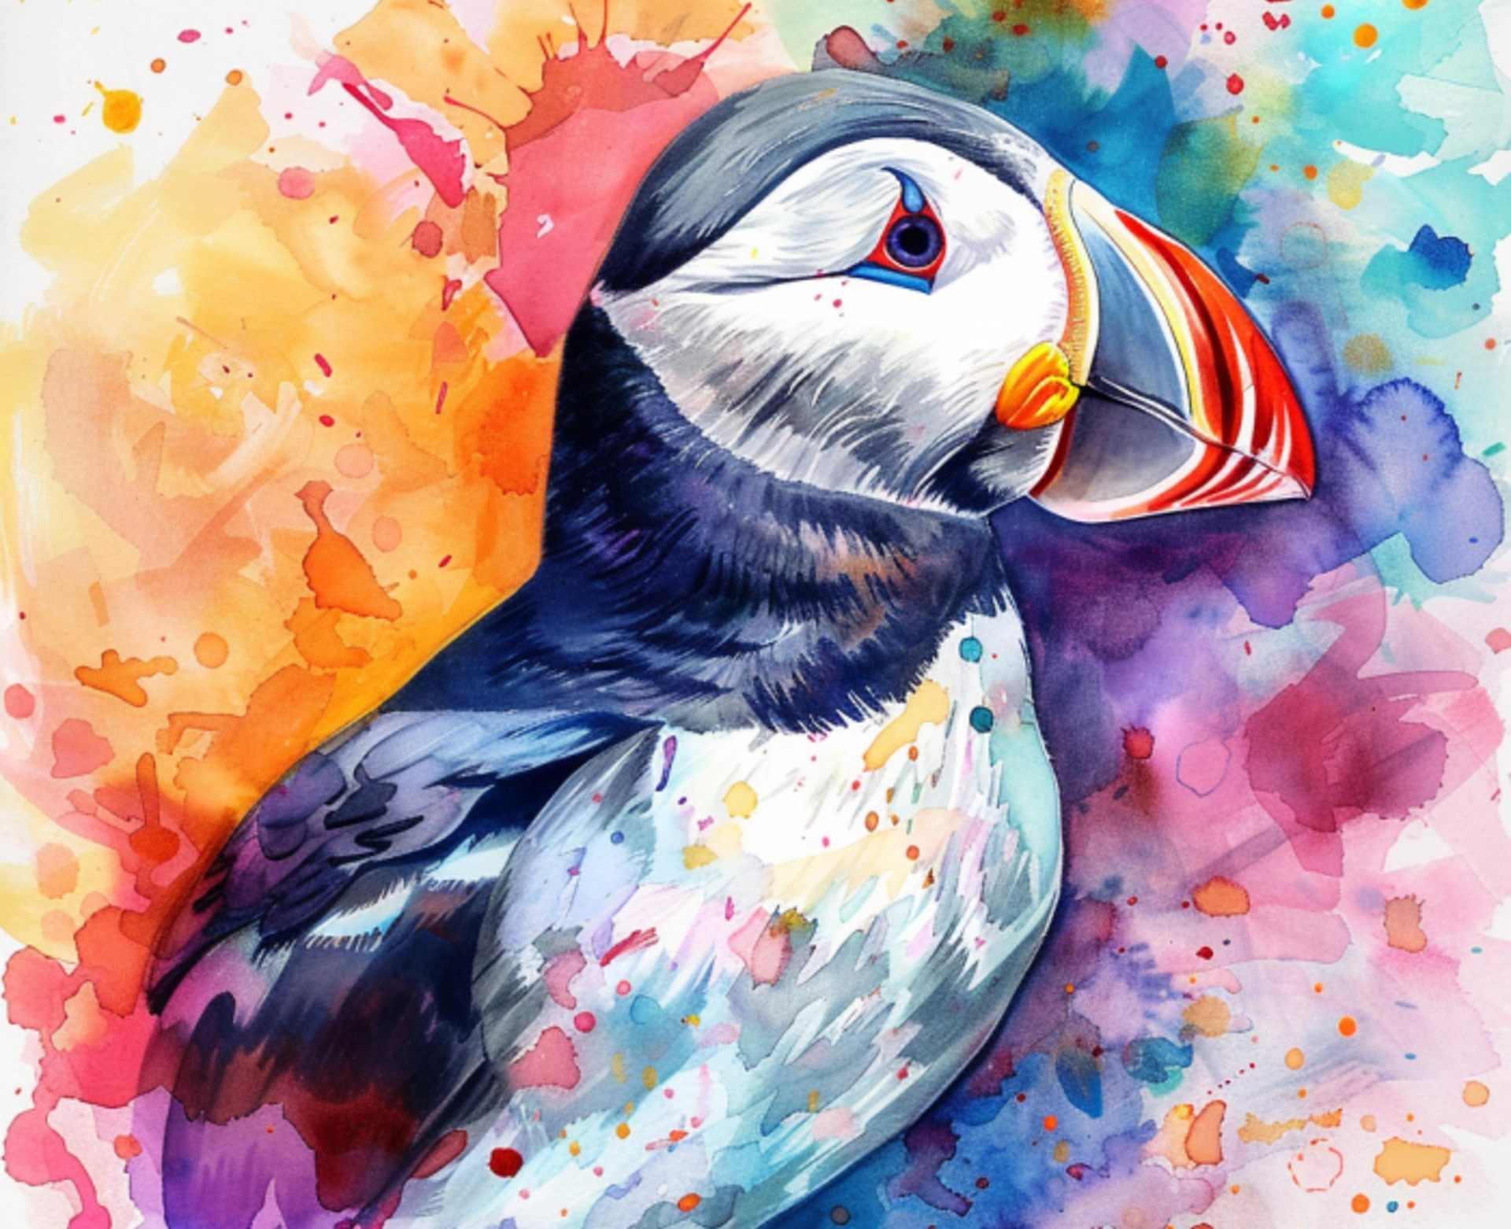

Image by nordstreamart from Pixabay

April 18th to 21st 2025
Bempton Cliffs, Cliff Lane, YO15 1JF

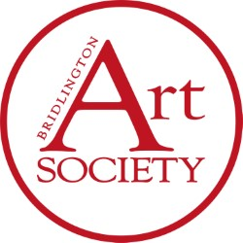

*No entrance charge is required to access the exhibition, but entry to RSPB Bempton Cliffs may include one
rspb.org.uk
Bridlington
ArtSociety.co.uk

