ART EXHIBITION at THE PRIORY
CELEBRATING the NATURAL BEAUTY
of BRIDLINGTON

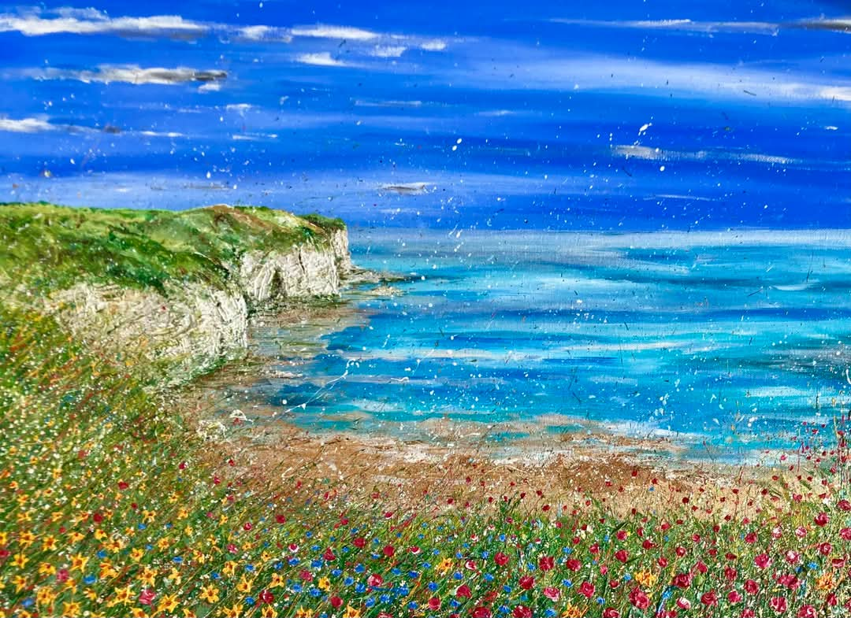


Art by Nic Draper

August 16th to 25th 2025
at Bridlington Priory, YO16 7BN

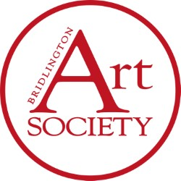

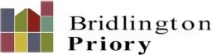
Bridlington
ArtSociety.co.uk

